The first thing I had to do was make the image to scale by editing the DPI

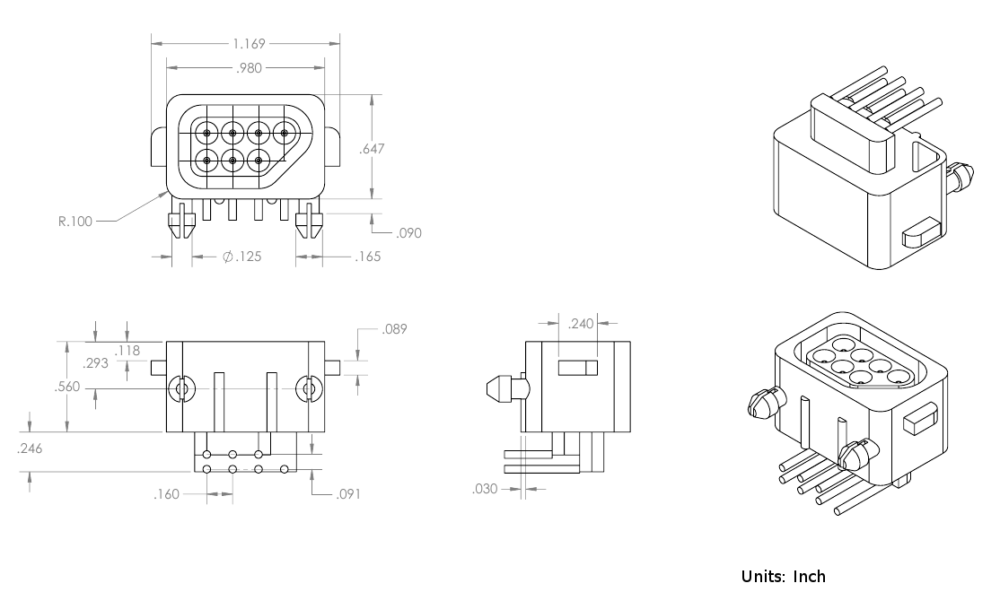

Here is the original image, but the DPI was wrong,

So using pixel math I calculated that the entire image should be 6.366 by 3.771 inches.

It can now be seen that the measurements are accurate

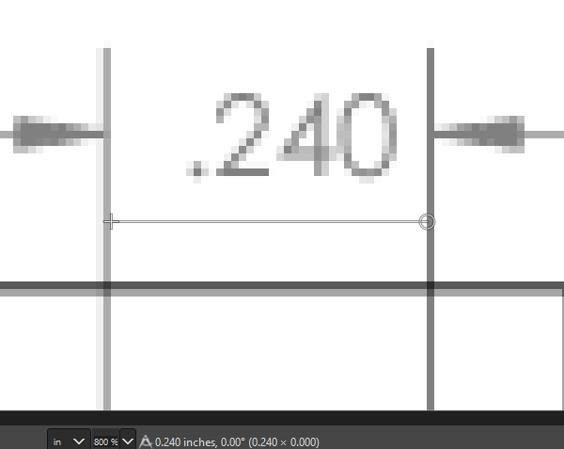

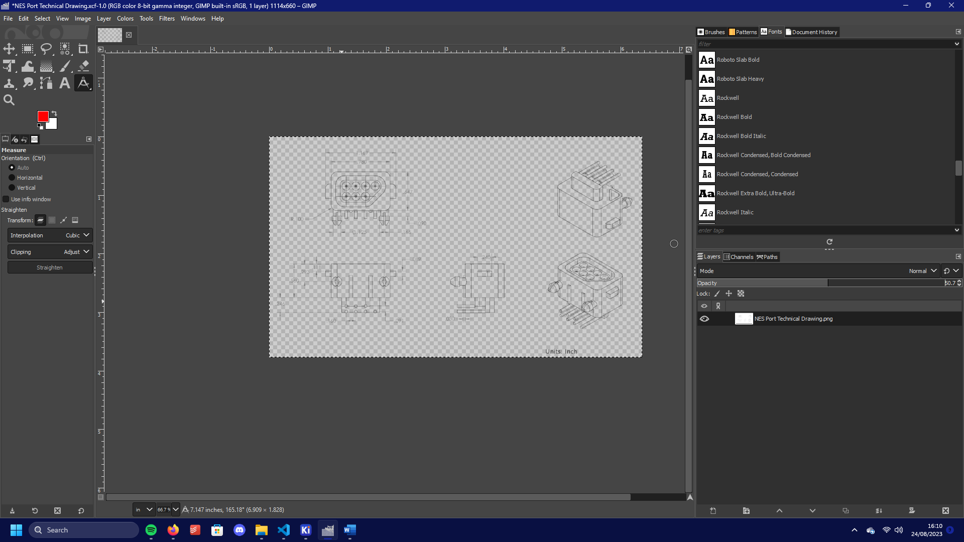

I also dropped the opacity to 50% to make the image easier to use in KiCad

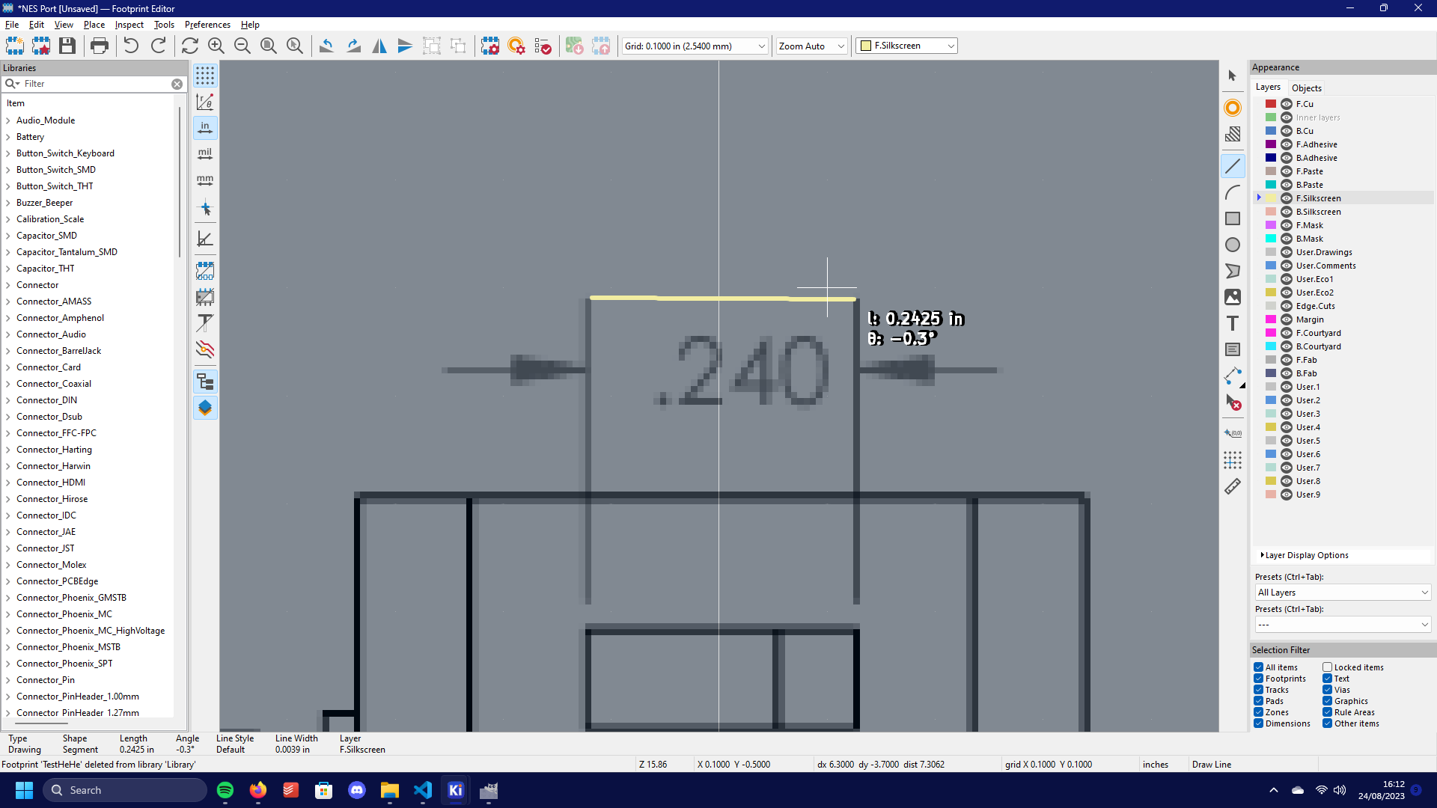

Measurements in KiCad Can now be seen to be to scale

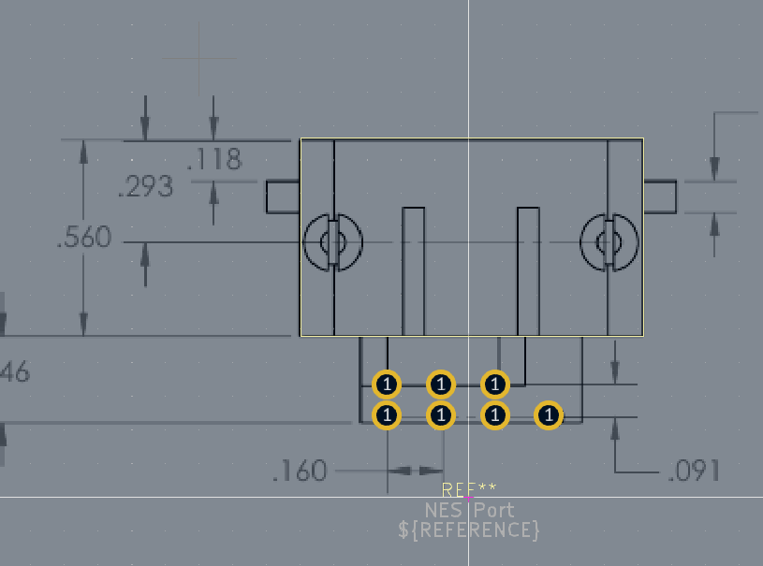

Start with the holes

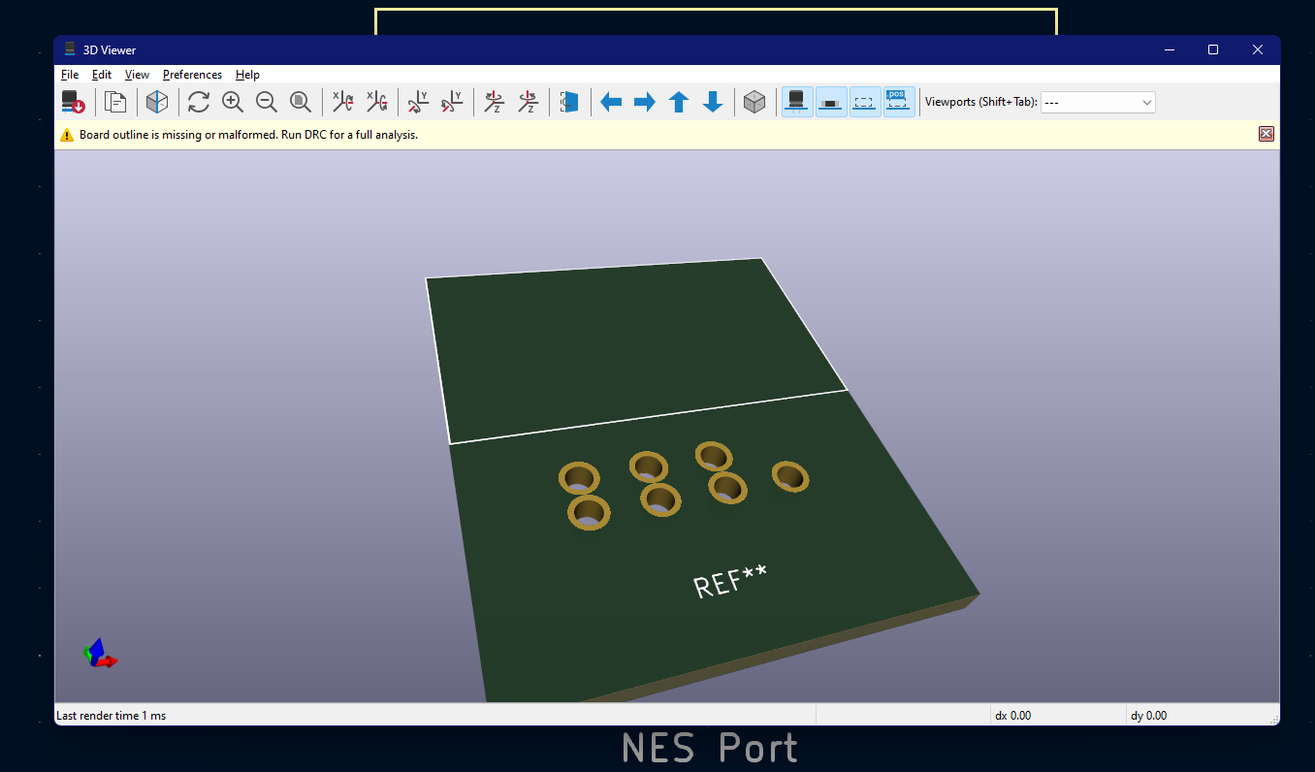

Progress

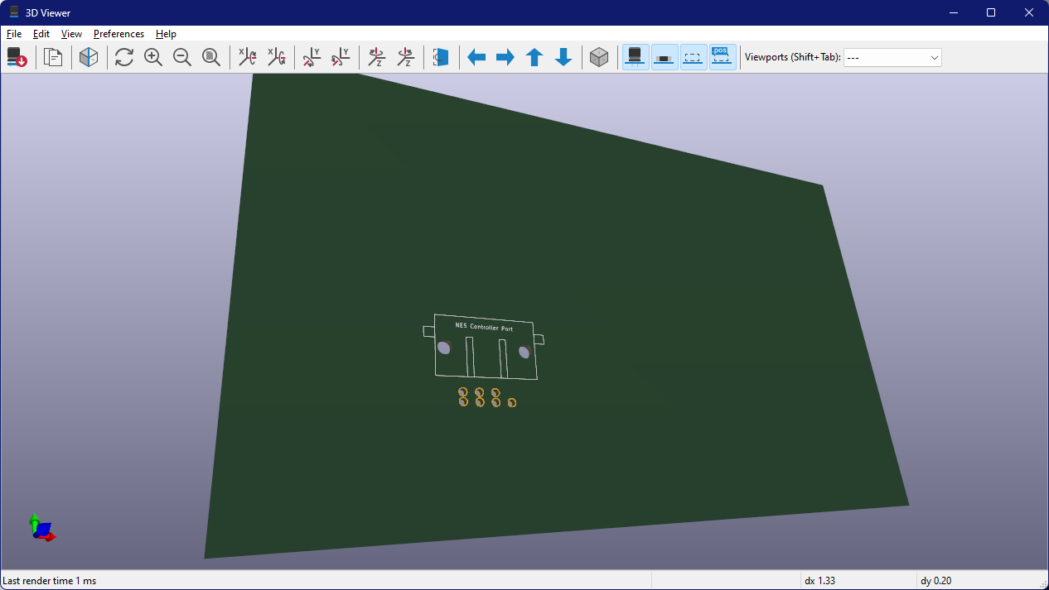

Ok the Port is done, I can start on the 3D model.

Modelling

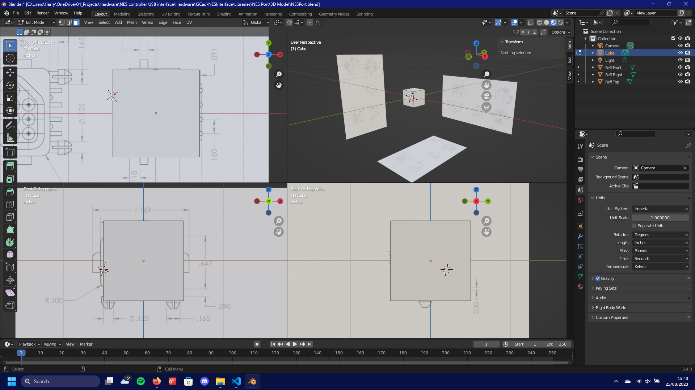

Started by putting the view in quad mode and importing and scaling my reference images

At this point the parts arrived, so I could double check me thesuerments, (Side note, I dint have qa battery for my micrometer so checkl put this janky setup)

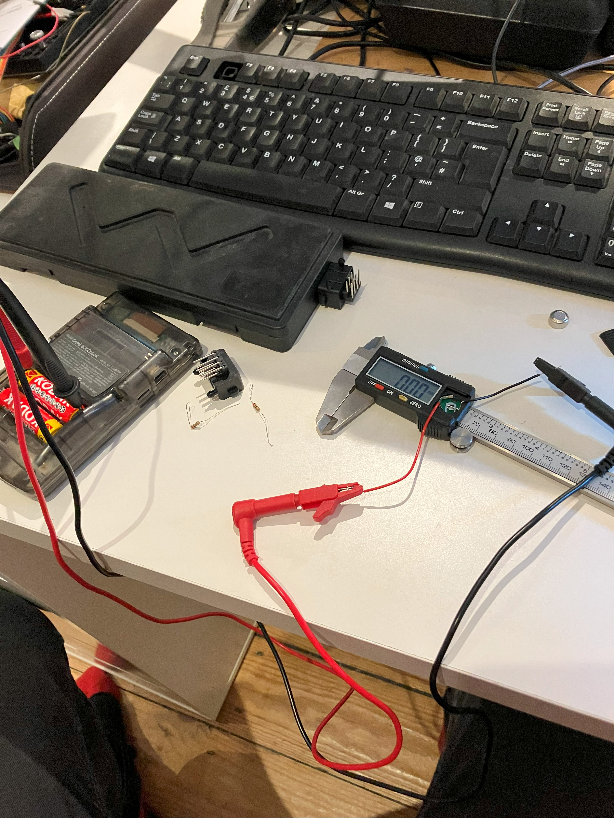

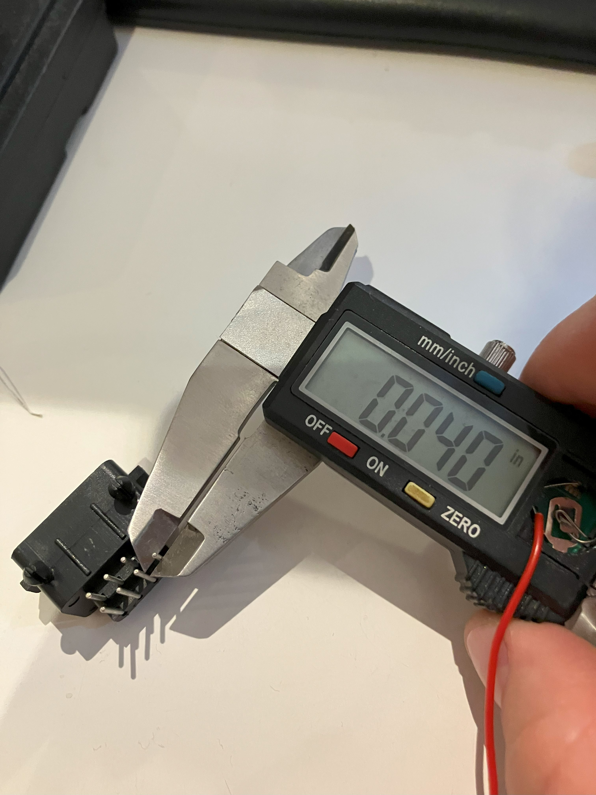

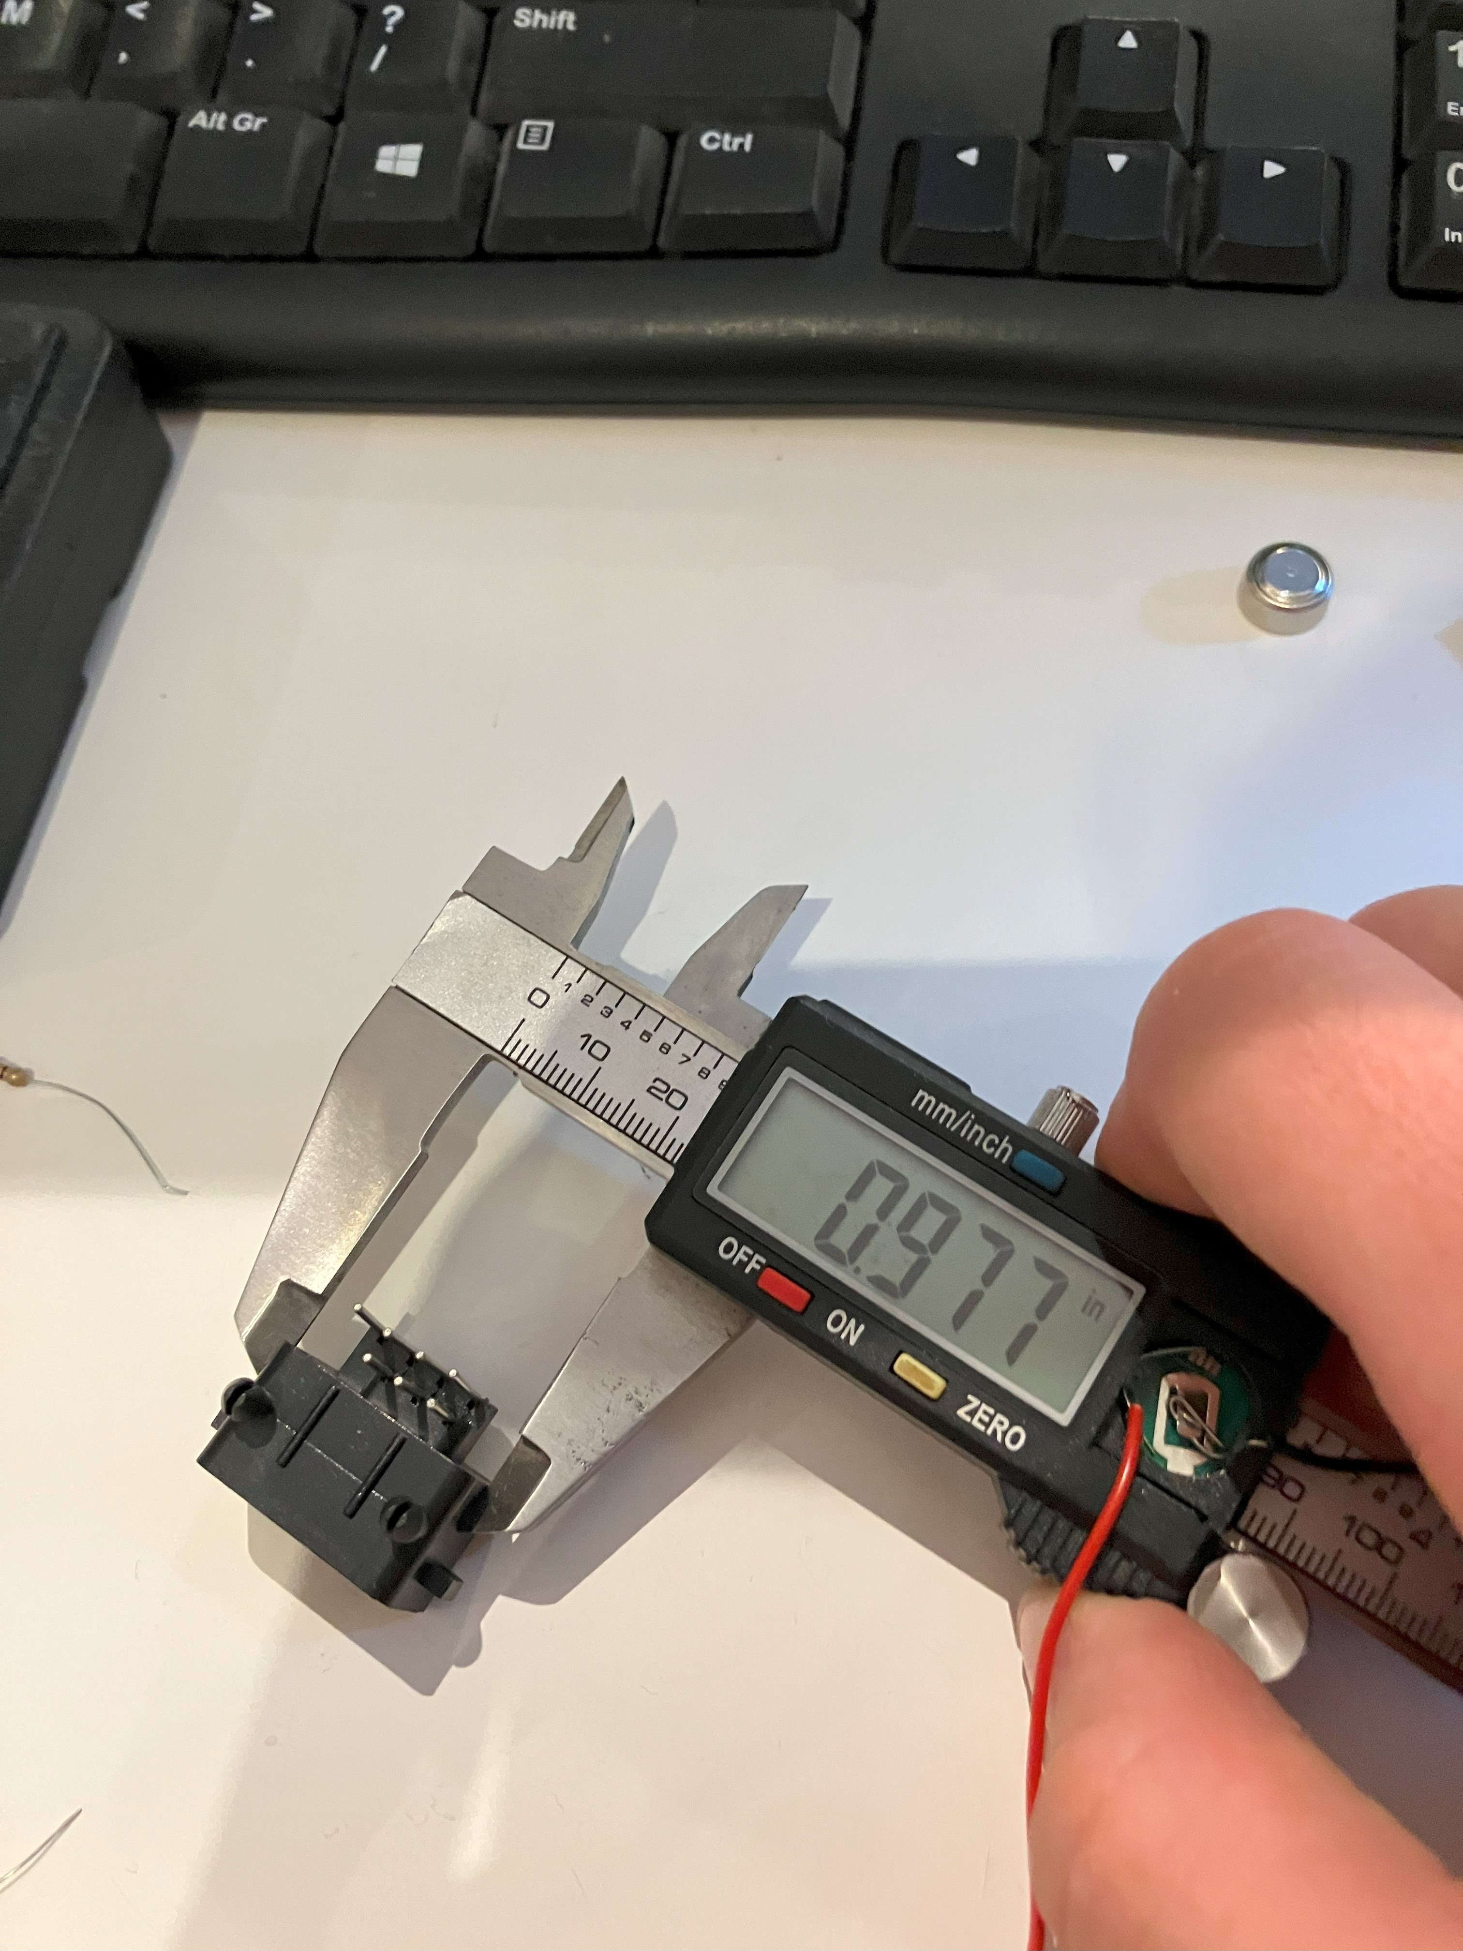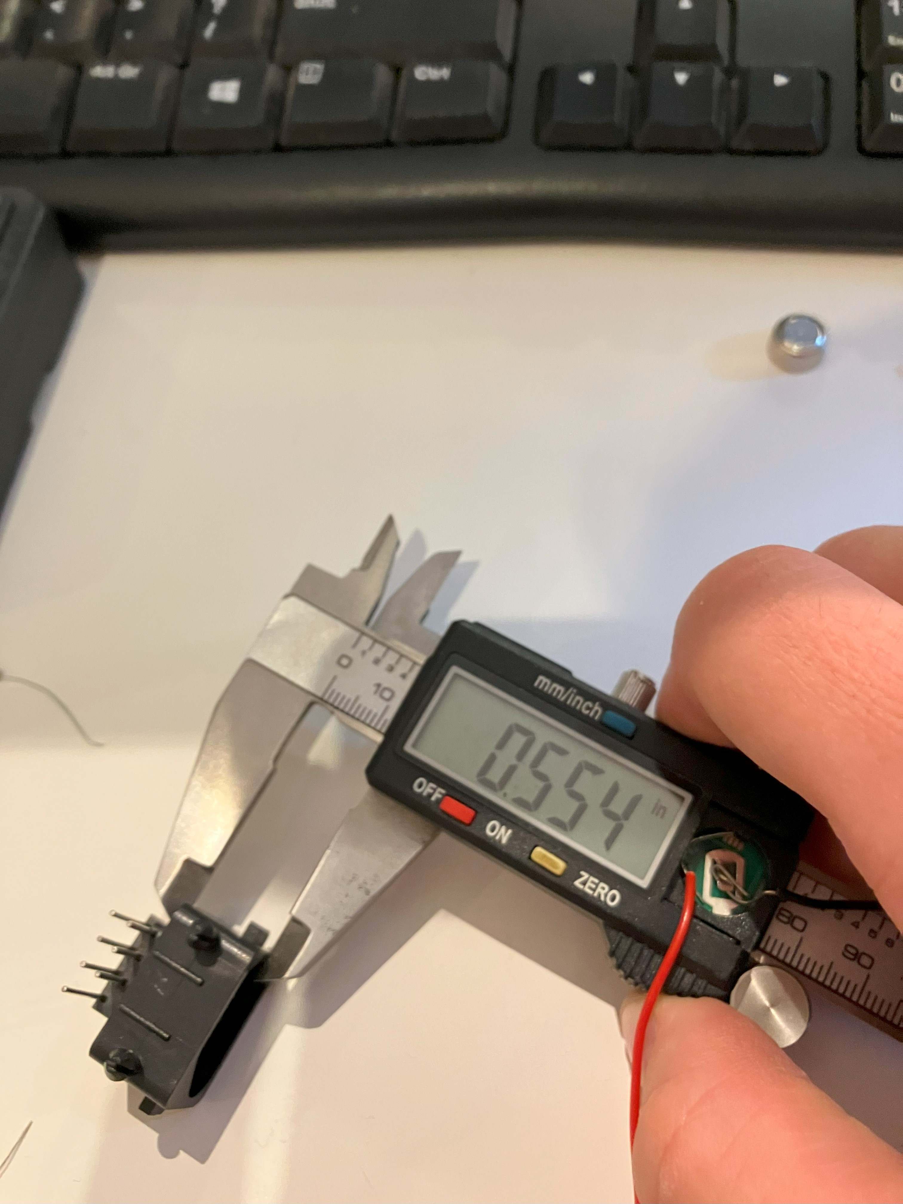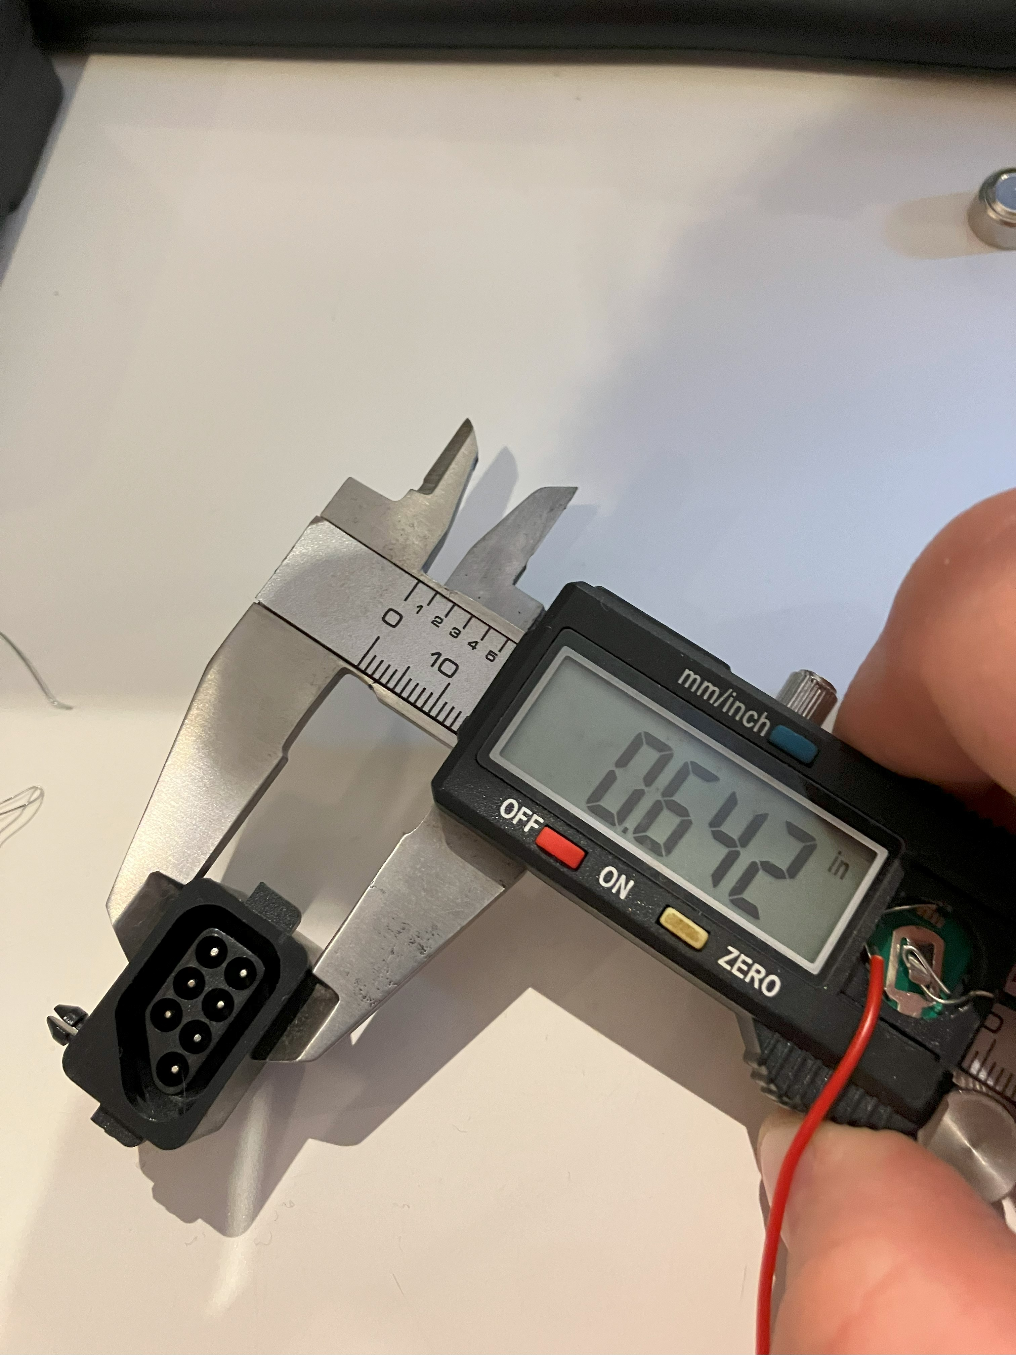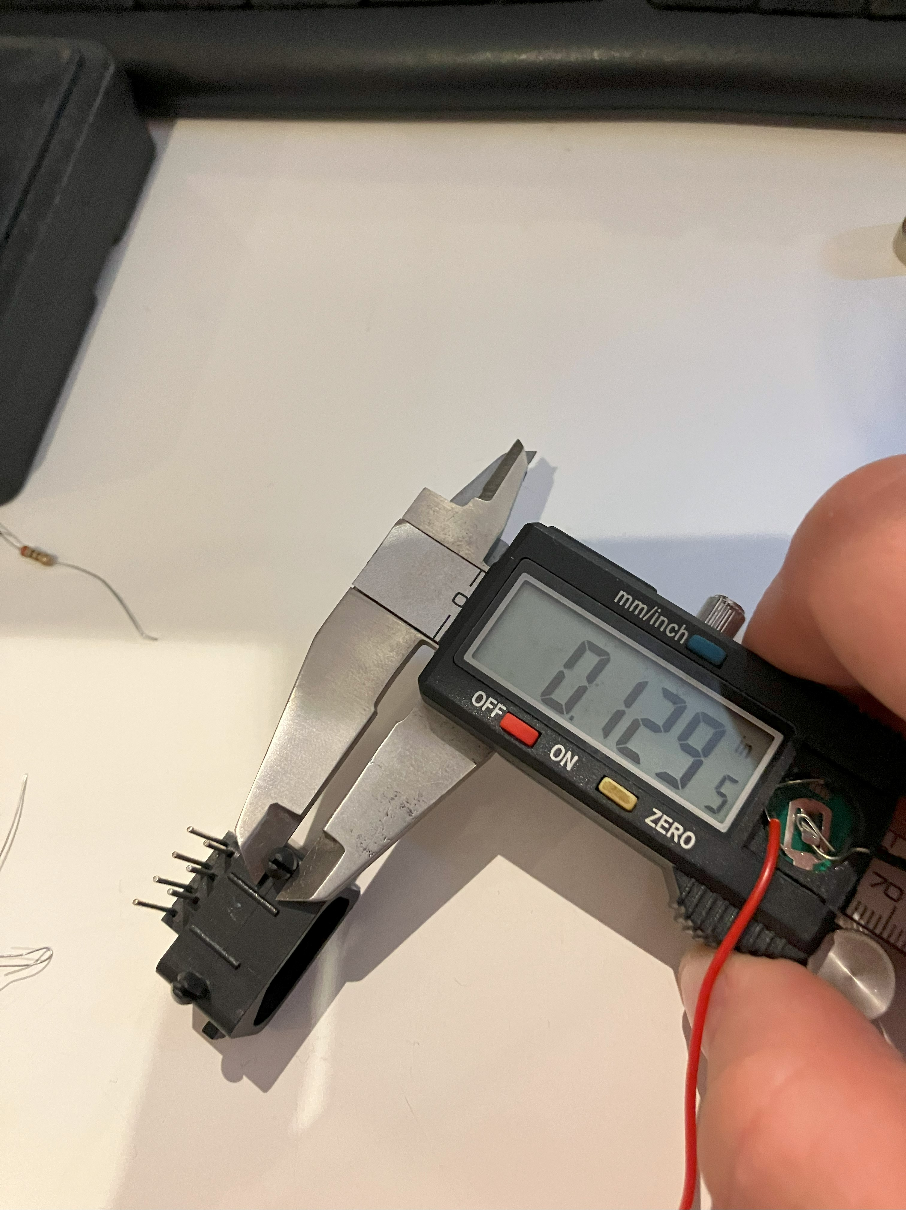

Yeah the measurements check out.

And its done

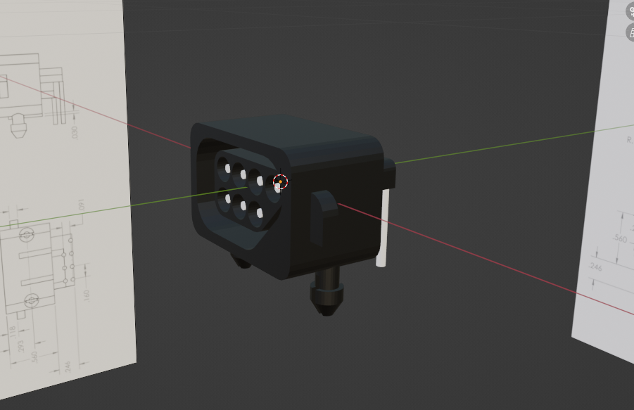

Then I

Changed the units to None, scaled up by 374.0 on every axis and separated the object by material

For both models I then Exported from blender, and imported into free Cad.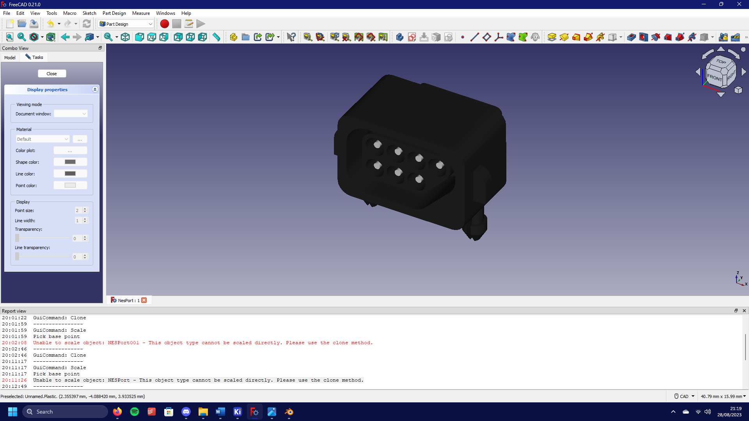

Reasigned the colours and exported the model as a wrl file.

I then put It into Kicad

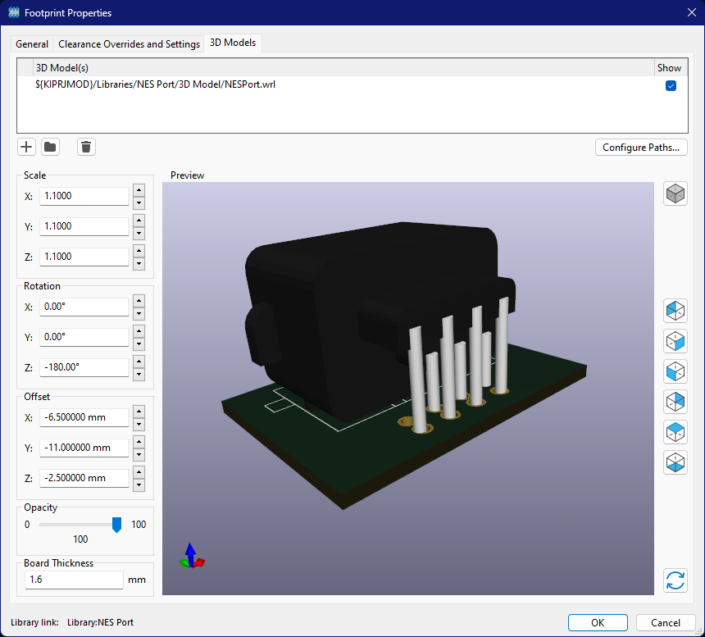it Worked, but it highlighted the fact that my footprint was wrong.

Ofcorse it it, becaxsue for some reason the view on the technical drawing is bottom up.